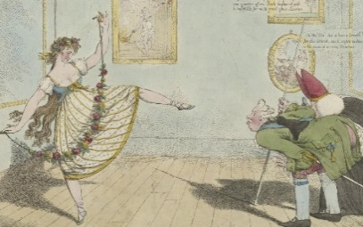
23rd Annual Oxford Dance Symposium
‘Watching dance, dancers and audiences’

New College Oxford
20th, 21st & 22nd April 2021

Registration Form
Please return the completed form by email to: Jacqui.julier@new.ox.ac.uk and ensure that the bank transfer is made by Tuesday 13th April.

Name and title:

Institutional Affiliation or Home Address:

Email Address:

Research Interests:

I have paid £25 by Bank Transfer to New College Oxford’s account

Date of Transfer: Signed:
Bank Transfer details for New College Oxford:

NatWest, Cornmarket Street Oxford
Sort code: 60-70-03 Account no: 01050605
IBAN no: GB32 NWBK 6070 0301 0506 05
SWIFT code: NWBKGB2L

Please note that you must pay for the symposium in advance, as no payment can be taken on the day. Late cancellations will not normally be refundable.
All enquiries to jacqui.julier@new.ox.ac.uk or jennifer.thorp@new.ox.ac.uk

