New College Fresher’s Guide 2018-19
Image Description: An image of garden quad, with a black gate in the foreground, and stone buildings behind the gate. Above it is a blue sky with clouds, and the words ‘Freshers’ Guide 2018-19’ and above that the New College roundel with the words ‘Manners Makyth Man’ and New College Oxford below it. At the bottom of the image is green grass

Table of Contents
Welcome! 2
What do I need to bring with me? 3
Preparation 6
Fresher’s Week 8
Life After Fresher’s Week 12
University and College Life 20
The JCR Committee – Executive 26
The JCR Committee – Non-Executive 34
Other Aspects of College Life 36
College Staff and Other Important People 39
FAQs 42
Extra Info 44

Welcome!

Welcome to New College. Congratulations on your exam results, and we look forward to seeing you in October.
This guide is organised roughly chronologically taking you through the end of the summer, your first day, your first week, and then giving some general advice. It’s worth giving this a read because hopefully many of your questions will be answered somewhere within these very pages.
Before you get here
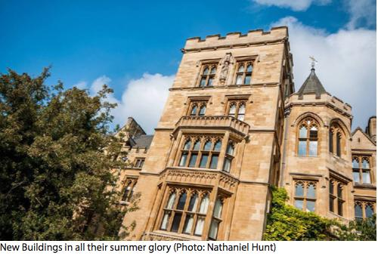
At this point, we hope you'll be enjoying one of the longest and work-free summers you’re ever going to get. Enjoy it, and make the most of the time you have at home. You’ll probably have lots of questions about what to do before you get here. You’ll want to know what to expect in terms of work, and the social side of life, as well as where you’ll be living for the next 3 terms. We hope that this guide answers some of the questions you might have, and gets you excited for all that's to come on the journey ahead.
A picture of New Buildings, a set of old stone buildings, with a tree in the bottom left corner and a blue sky above the buildings. Accompanying text says: New Buildings in all their summer glory (Photo: Nathaniel Hunt)

Why haven’t I been asked to choose accommodation yet?
First off, don’t worry that you haven’t been sent anything about choosing accommodation. You’ll be assigned a room, so don’t need to sort anything out yourself. First year rooms range from the mediocre to the ridiculously good. You will all be living in New Buildings, which is one of the best, and most sociable, accommodation blocks in Oxford. Get in touch with Sam (our housing officer) if you want any info about your room at: sam.krasner@new.ox.ac.uk
In your room, you will have a bed (most are singles but there are a handful of doubles), bedside table with lamp, a desk with lamp, a fridge, an Ethernet point and chairs. You will either have an ensuite, or access to a shared bathroom. College doesn’t provide bedding, so you’ll need to bring this with you, or order it to be sent to College. You’re also able to personalise your room in whatever way you choose (within limits!). Your room will be cleaned each week by a scout. They are very friendly, as long as your room is reasonably tidy when they come round.
You’ll have access to our brand-new laundry facilities (including washers, dryers and irons), food in Hall, and IT and printing facilities. You won’t have access to a kitchen, but it’s still possible to make some food in your room.
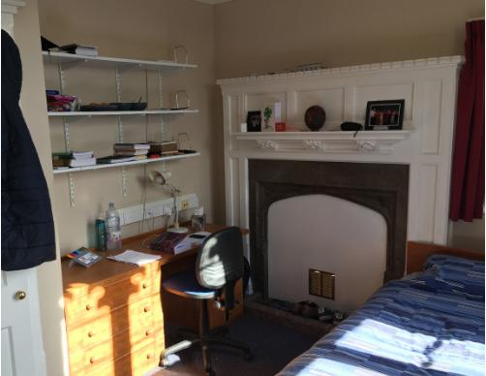
Image Description: A picture of a bedroom, with a bed with blue sheets on the bottom right-hand corner. Next to the bed is a filled-in fireplace, with several cards and objects on the mantle. On the left is a desk with a lamp, bottles and some books, above which are shelves with books on them. On the left is a closet with a jacket hanging off it.

What do I need to bring with me?

General living:
- *Bedding* (remember a duvet and pillows) If you need to borrow this, email the housing officer.
- Towels
- Toiletries
- Washing powder
- Coat-hangers
- Laptop (and charger)
- Mobile phone (and charger)
- Ethernet cable (if you want to get onto the Ethernet rather than Wi-Fi - advisable as Eduroam can be unreliable)
- Extension cable (multiway adaptor)
- Posters and pins
Food stuff:
- *Kettle*
- Cloths and tea towels
- Washing up liquid
- Mugs, tumblers, wine glasses, shot glasses etc.
- A few plates, bowls and cutlery
Image Description: An image of a black kettle from Russell Hobbs. Accompanying text says ‘The Kettle – a woman, man or non-binary person’s best friend
Administration:
- **This guide**
- Money and bank cards
- ID (passport and/or driver’s license)
- For opening bank accounts, and for getting into pubs and clubs.
- Passport photos (useful for Union membership, coxing licenses and other extra-curricular activities)
- LEA/ finance information
- Medical details
- Sports kit

Work stuff:
- Stationery
- Folders
- Dictionary
- Calculator (subject specific, probably don’t need this if you do English)
- Paper and Notebooks
- Any relevant old notes – You might not use these, but they can be reassuring.
- Hole punch
- Stapler
- Scissors
Clothes:
- Whatever it is that you like to wear, including clothes for the wet and windy Oxford weather, and for the occasional time when the sun makes an appearance.
- Sub fusc (This is what we wear for exams and for matriculation)
- Fancy dress stuff for bops
- Black tie (if you have it)
Subfusc
This is Oxford’s academic dress. You wear it for matriculation (a ceremony where you are formally admitted to the University - you only have to turn up and you get brunch after), and for exams. Subfusc is:
- dark suit with dark socks and white bow tie or black ribbon OR a black skirt with black tights OR black trousers with dark socks
- a plain white collared shirt
- black shoes
- a gown and mortarboard
There are loads of shops in Oxford, where you can buy these things once you arrive. They usually come in a package with a black ribbon or white bow tie
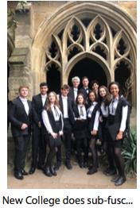
Image Description: A group of 11 people wearing sub fusc with the cloisters in the background
Storage
The JCR and College run an external storage scheme where you can store the things you don't need to take home every vacation securely at Charles Wood and Sons (our external storage provider). College funds some free storage for the following groups of people: international students, students from Scotland, Wales, NI or Channel Islands, students who live more than 4 hours away from Oxford and students whose family/friends cannot pick them up at the end of term. Sam, your housing officer, will be in touch with more details about this later in term
Optional extras:
- Cushions, rugs, teddy bears, plants, books, films, photographs and anything else that will make your room feel more like home.
- Musical instruments
- A printer. Yes, you can use college printers, you just might find having your own a bit more convenient.
- Bike. Bring one with you, or buy when you get here, there are loads of second hand bike shops.
Stuff you are NOT allowed:
- Toasters, ovens, microwaves, electric paella pans
- Pets
- Cars
- Candles (decorative or otherwise) and other fire hazards
- Offensive weapons
- Blu-tack (It damages the paint on the walls, but you do get a pin board for posters and stuff)

Preparation

What work should I do beforehand?
Your tutors should have got in touch to let you know what work they expect you to have done before you start. You may have a reading list to work through. Your subject rep, will probably have recommendations for books that are really important or suggest places to look for useful resources. Don’t be afraid to get in touch and ask them any questions.
Anything else I need to sort out?
Yes. Firstly, you’ll need to fill in the forms that you were sent in this pack, including the passport sized photo for your Bod Card. You’ll have this card for all the years of your degree, so make sure it’s a photo you don’t mind looking at every day. More on the Bod Card in a bit. Unlike a passport photo, you can smile for your bod card photo!
Secondly, you’ll have been given a booklet of information about IT, and it’s a good idea to read this and sort that out before you arrive. It shouldn’t take too long to set up your Single Sign On account and your access to Eduroam.
Your Single Sign On is a really important username and password combination, that enables you to access, among other things, your online library account (SOLO), Weblearn (Oxford’s virtual learning site), and your emails.
It takes the form newcXXXX and the password can be changed to one of your choice. Make sure to write this down as it’s easy to forget things in the hustle and bustle of Fresher’s Week.
You’ll also be able to access your Oxford email using your Single Sign On. Once set up, you can access it from owa.nexus.ox.ac.uk. Anyone will be able to email you on first name. surname@new.ox.ac.uk. (If in doubt about other people’s email addresses, you can search for currently active Oxford nexus email users here: http://www.ox.ac.uk/staff)
Eduroam is a Wi-Fi network that you can access from University buildings around Oxford, and at University campuses worldwide. It’s worth bearing in mind that you do need to register your logon and password for this before you get to Oxford because you can’t
do it over College Wi-Fi (although don’t worry if you haven’t, it does work over 3G). Eduroam has a different username and password combination to your Single Sign On. The logon takes the form FIRSTNAME.SURNAME@NEW.OX.AC.UK and you set a password of your choice.
I’M AN INTERNATIONAL STUDENT, DO I NEED TO DO ANYTHING DIFFERENTLY?
As an international student, you’ll be arriving at College a few days before the UK students, which will give you time to attend the Orientation Programme and do things like setting up your bank account (if you need to). Also, a few things are on our packing list that you shouldn’t bring with you, but should instead buy in Oxford. If you have any more questions, get in touch with Ailidh or check out this University website: ox.ac.uk/ students/new/international?wssl=1)
Don’t bring, but buy
- Kettle
- Pillow and duvet (purchase online at www.galilarde.com/oxfordnew and have them sent to the College before you arrive; a small number of rooms have double beds so check with the accommodation manager (sue.fisher@new.ox.ac.uk) before you arrive)
- Mugs, glasses, plates bowls cutlery etc.
- Coat hangers
- Bike
- Too many cold weather clothes if you’re from a warm country (they tend to be of better quality and last longer if you buy them in town, although they can be more expensive)
Phones in the UK:
Since you probably won’t be in the UK for the full year we recommend getting pay-as-you-go. Giffgaff has a nice offer with unlimited texts, 250 UK minutes and 750MB of mobile data for £7.50 per month. You can order your sim card online and have it delivered to College so you already have it before you arrive (YOUR NAME, New College, and Oxford, OX1 3BN). For international calls, Skype is a good option, or you could get your SIM card from Lebara, which has reasonable per minute prices for international calls.
Think about banking:
You should check whether your bank has a branch in the UK or a cooperation with a UK bank. Otherwise, Oxford SU Fresher’s Fair will give you the chance to chat to different UK banks if you’re undecided. You’ll also be able to set up a bank account there and then, if you have the necessary documents (A valid passport or EU identity card and a student enrolment certificate (you need to get this stamped by College and can ask the International and Overseas Students officer, Ailidh Finlayson email: ailidh.finlayson@new.ox.ac.uk for help with this.
Transferring money:
If you want to pay your battels/tuition fees from a foreign bank at the beginning of term, we recommend using transferwise.com. It will save you the complications that might arise from different currencies and additional fees.

Fresher’s Week

WHEN YOU GET HERE
Do I arrive on Monday or Tuesday?
You’ll be arriving early if you’re an international student.
If you're not an international student but have a genuine reason why you need to arrive on the Monday you may be able to arrange this with College (student.services@ new.ox.ac.uk). Most people should arrive on Tuesday. You’ll need to get to College sometime between 10am and 4pm.
What do I do when I get here?
Parking
You’ll be able to park on Holywell Street. There will be a team of people in brightly coloured T-shirts to help you. (They are the JCR committee and subject representatives.) They will get you a parking permit, so you’ll be able to leave the car on the street for 20 minutes or so.
Collecting your keys
Head to the Porters’ Lodge, where you can collect your room key. The porters will tell you where your room is, and the person who is helping you out will be able to take you there.
Registering
The person helping you will take you to Lecture Room 6. Here, you’ll need to register for your student loan, and pick up your Bod Card (University card). You will have your photo taken for the who’s who as well, so you can get to recognise everyone in your year as soon as possible.
The Bod Card

It’s simultaneously a debit card, ID, discount card, library card and a key into various university departments, and to the rooms of New College itself. It’s yours for your whole degree. It’s called the Bodleian card for long. You use it to buy food and drink in College.
It is worth using a good photo as it's pretty much fixed for all your time here - remember that, unlike in a passport photo, you *are* allowed to smile!
Image Description: A picture of a bod card with Sir Christopher Wren as the photo placeholder. It says University of Oxford along the top, then ‘Christopher M Wren’, followed by ‘UNDERGRADTUATE reading for MMathPhil Mathematics and Philosophy’ then ‘Mathematical Institute’, then the number 136, then the number 12345, then the letter S and the number 2804772. It says valid until 30 JUN 2017.
Unpacking
Unloading everything from the car into your room shouldn’t take too long, with the help of a friendly second year. If your room is at the top of several flights of stairs, don’t be afraid to ask for help with the heavy bags - the person showing you up isn’t allowed to complain!
Fresher’s Marquee
Once you’ve got all your stuff up to your room, and waved goodbye to your parents or whoever brought you, you can head down to the Fresher’s Marquee in Holywell Quad. It will be clearly signposted so don’t worry about getting lost.
There will be committee members and other Freshers all milling about in the marquee. The second years will be running frequent tours of College in groups so you can get acclimatised to the layout of College pretty quickly. There will be free food and drink in the marquee all day and plenty of people to talk to.
THE MAIN PROGRAMME KICKS OFF
At around 4pm, once everyone has arrived, the JCR Officers and the Student Support Team will introduce themselves and the plan for the week. We'll then have dinner in Hall and have a battle of the staircases quiz!
Your first week
After the mad rush of your first day, you can settle down and look forward to a week full of fun and frolics, with a couple of necessary tasks thrown in too. You’ll be able to see all this looking at your Freshers’ Week timetable. We will email this to you ahead of Freshers' Week and you'll get a copy when you arrive.
During the day
Necessaries:
You may face a bit of an information overload, since you’ll be getting a fire safety talk, several library inductions, and probably computer room sessions. We’d advise you sort out all the IT stuff as soon as possible, as it will make things easier later on if you aren’t struggling to get on the Wi-Fi. You’ll also get to meet your tutors properly for the first time since they interviewed you. Most people end up getting on really well with their tutors so don’t be scared by this.
Fun stuff:
When you have time between your compulsory information sessions and sorting out admin bits and bobs, there will be loads of activities going on within College.
There will be MADD (Music, Arts, Dance and Drama) and sports events going on to show you what life is like outside the library. The New College Fresher’s Fair will have a number of stalls by different sports teams and societies within College, so you’ll get a good idea of what’s going to be on offer throughout the year.
You’ll also visit exam schools for the HUGE Oxford University Fresher’s Fair where you’ll no doubt sign up for a hundred clubs you never knew existed, and will spend the next few terms trying to remove yourself from the mailing list of that club you never once went to. However, you’ll find something that suits you perfectly - there is truly something for everyone, from the Cocktails Society to the Historical Re-enactment society, a cacophony of choirs and orchestras, and every sports team imaginable.
At night
You can look forward to some great entertainment throughout the week co-ordinated by our brilliant Entz Reps, Charlotte and Michael. You’ll be able to visit some of Oxford’s premiere nightlife venues, experience the LEGENDARY New College Toga Party, and enjoy your first of many awesome bops! (Bop: noun - A party in college organised by students, with a fancy-dress theme. Each college has two or three of these per term. The quality varies widely, although we think New College’s are undeniably the best). The first bop of the term will be Cops and Robbers. Make sure you have a good costume! We'll also have some supplies in College to make a costume that night in the JCR.

Image Description:

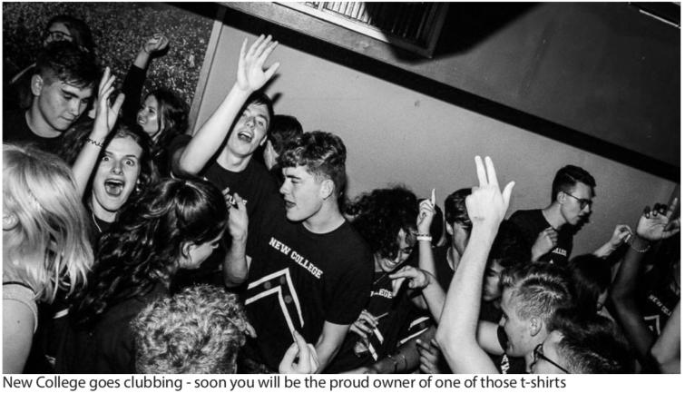
Image Description: There are people in a room with their hands raised, wearing shirts that say ‘New College’ and they’re shouting something. The image is black and white. The text below reads: ‘New College goes clubbing – soon you will be the proud owner of one of those t-shirts’
Congratulations if you make it out every night of Fresher’s week! But you’re certainly not expected to; we’ve got loads of other events planned. Expect a Scavenger Hunt trips to G and Ds (legendary ice cream parlour), and more. There are some really exciting things in the pipeline so look out for the announcements of what’s going on!
Your first week’s nights out are all planned out for you:
Tuesday - Parkend (Atik - but don't call it that...)
Wednesday - Cellar
Thursday - Parkend
Friday - JT's
Sunday - Fever (College Bop)
So many new people and new things! I feel a bit overloaded.
If you feel lost or disoriented during the week, don’t worry, it’s perfectly normal and happens to everyone. You could also track down your College parents who will be happy to chat to you, show you around and answer any questions. Fresher’s Week is great fun, but it can also be overwhelming; don’t worry if it doesn’t live up to the hype and isn’t the *best week of your life ever*; you’ve got so many more great experiences to look forward to in the next 9+ terms of Oxford, and it’s perfectly normal to take a bit of time to adjust to new things.

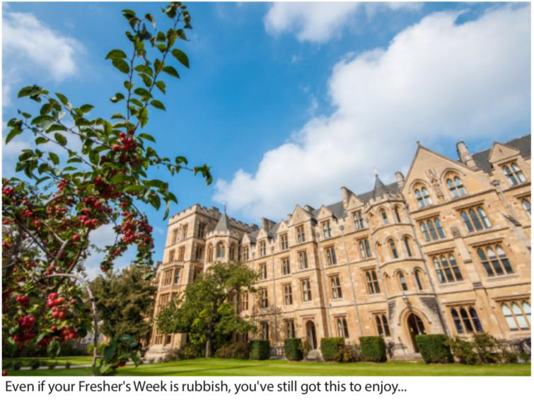
Image Description: An image of New Buildings, the buildings take up the majority of the foreground from the center to the right edge of the photo, a plant takes up the left side of the foreground. In the background there is a blue sky with clouds. The accompanying text reads: ‘Even if your Fresher’s Week is rubbish, you’ve still got this to enjoy…’

Life After Fresher’s Week

WORK
There’s no denying that work is a big part of life at Oxford! You’ll note that it’s a bit different from school! Firstly, and most importantly, you will have tutorials ('tutes') a few times a week. These happen with your tutor, either individually or as part of a small group. It’s an amazing way to learn from others and gives you the chance to develop and defend your own opinions rather than just getting a few comments in red ink at the bottom of your essay.
For each tutorial, you’ll be set work, probably the week before either an essay or a problem sheet. Usually this work will form the basis of the discussion.
For science subjects it’s often a good idea to hand in any rough work for questions that you haven’t managed to complete fully, as then the tutor may be able to see where you’re going wrong.
Another big change will be lectures. For many undergraduate courses, some or many lectures are essential, for some other courses, they will be optional. If you are in any doubt about which lectures you should be attending, please speak to your tutors in the first instance. You will get a lecture list for each term; most departments will put this on their websites or on Weblearn as well.
You’ll notice pretty quickly that you get loads of freedom at university. There won’t be anyone reminding you to work, which means you have to motivate yourself and find a pattern that suits you. This is something you’ll probably figure out after your first late-night essay crisis.
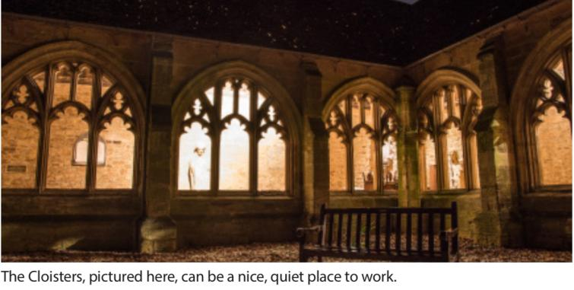
Image Description: This is a night-time image of the cloisters, with a bench in the foreground and the night sky in the background. Accompanying text reads: ‘The Cloisters, pictured here, can be a nice, quiet place to work’
Many people find it easier to concentrate if they work somewhere other than their room; the College and University libraries (especially the fabulous Bodleian), the café area, and even coffee shops around the city may be good options.
At the start of most terms (except first term), you’ll have Collections, mock exams on the previous term’s work. Your first Collections will be in January 2019.
If you do have a problem with work, however trivial it may seem (even struggling with procrastination can be something it’s helpful to get advice about), don’t hesitate to contact someone. Your tutor, or one of the second years doing your subject can be a good starting point. Another option is the Academic Affairs Officer, Anna Wilson, who is always available to chat about work worries. Everyone here at New College wants to help you enjoy your subject so that you can achieve your full potential!
PRACTICALITIES
FINANCES
Before you arrive at Oxford it can be hard to estimate how much money you will need. To make this easier we have tried to make clear everything you’ll need to pay for during your time at Oxford.
Battels
Battels are the charge you have to pay to College at the beginning of each term. They include the cost of accommodation, and evening meals. In later terms, they’ll also include anything that you’ve ‘put on battels’ during the previous term.
Battels need to be paid by mid-day on the Friday of 1st week of each term. Your battels statement will be emailed to you at the beginning of 0th week of each term (Freshers' Week is considered 0th week). Your first battels will be due by Friday 12th October. There are two ways to pay, either hand in a cheque at the bursary, or pay by debit card or credit card (beware 2% extra surcharge for credit cards) online. You do this through the meal booking website. Simply log into the meal booking website (food.new.ox.ac.uk) and click purchases and payments, then 'Pay Battels'. The cost of battels is just under £1700 not including any optional extras.
Be aware that hidden costs can build up on battels, because many in-College events are paid for using this system. For example, club tickets in Fresher’s Week, sports team photos or charity calendars. Don’t let the hidden costs build up; if you want to keep track of how much you’ve spent you can check your current bill online in the same place you pay battels, or you can email Linda Goodsell at linda.goodsell@new.ox.ac.uk. For most UK student’s tuition fees are automatically paid to College by the Student Loans Company. However, if you are an international student, or are choosing to pay fees yourself, then these fees also appear on your battels statement and can be paid using the same method.
Grants and bursaries
Oxford is one of the most generous universities in the country bursary-wise. The University bursary scheme gives money to all students whose household income is less that £42,620. As long as you ticked the box, “I’m happy to share this information with universities” on your Student Finance Application, this is all sorted out automatically. It’s also worth looking at www.ox.ac.uk/admissions/undergraduate/fees-and-funding to see the full range of bursaries available, and find out if you are eligible for any extra financial support.
Cost of living
On top of paying your Battels, you will need money to keep you going on a day-to-day basis. This will cover breakfast, lunch, evenings out, spontaneous shopping, etc. You’ll pay for food in College on your tills account (find out more about this in the food section below).
You may well spend a lot more in your first term, particularly if you decide to buy your own books or to join many societies. Most societies cost around £10-30 to join, but some do life membership, whilst others charge you termly fees, known as subs. However, planning for this sort of expenditure in advance and deciding what you think you will get good value out of in later terms can be invaluable. There is no real average for what people spend because it depends so much on your lifestyle (not drinking alcohol saves you a lot of money for instance!).
Having said that everyone’s different we wanted to give you a general idea of costs:
How much does it cost week to week?
- Sandwich at the ATS: £3-4
- Night out: £5 for club entry, £8 for pre-drinks +drinks out = £13+
- Pint at the Turf Tavern: £4-5
- Drink in the College bar: £2-3
- Lunch in Hall: £3-5
- Breakfast in Hall: £0.50-3
- Cereal and milk from Tesco: £0.75+ +£0.89 = £1.54
- Tesco meal deal: £3
- Society membership: variable
  - E.g. History Society Membership: £15 (£12 during first week), talks free and socials £2 for members (£1 and £5 respectively for non-members).
  - E.g. Oxford Union Life Membership: £223 during welcome period (£248 otherwise) Lower membership fee available for those on bursaries.
- Trip home: depends on where you live
- Ball tickets: £40-200, depending on the ball
Example expenditure per term:
This person budgets around £84 a week. Not everyone lives like this and you may well find even if your budget is similar, it breaks down completely differently. Also, it is just an example and it is possible to spend less (or significantly more) than this amount.
How much does it cost, per term?
- Battels = £1690
- Food £35/ week for food (e.g. Alternative Tuck Shop sandwich for lunch, cereal, brunch in hall, plus snacks) = £280
- Club nights 15 times a term, at £10 a time = £150
- Society memberships e.g. History society £12, £6 for a social x3 = £30
- Laundry (8 sets of washes and dries) = £20
- Drinks in the bar (2 pints a week) £2.50 x 2x8 = £40
- Crew date (£15 curry plus £5 club entry, £5 bottle of wine, £5 of drinks) x 2 = £60 • Guest night (£15 ticket +£10 wine) x2 = £50
- Makeup/toiletries = £40
- Vacation storage = Free for most people!
= Total spend £2360
Living out
While New College provides accommodation for the first two years of your degree, unless you are doing a course which incorporates a year abroad, you’ll probably need to live out in third year. There are a few third-year rooms in College, but not enough for everyone. Whilst you won’t necessarily be thinking about this now, it could be useful to have an idea of what to expect. We estimate that rents are usually £380-470+ per month. Then bills are £30-40 a month, TV licenses are £36 annually, and food costs £20-40 per week. On top of this, other costs like going out, playing sport, books etc. will also apply. You also have to pay housing costs year-round, rather than just during term times as you do in first and second year.
Financial support
If you need any more information about Battels, general advice about finance from the Bursar, or more information about loans and grants, visit www.new.ox.ac.uk/finance. There’s a great document which gives you information on all of the New College bursaries as well as financial advice to be found at http://www.new.ox.ac.uk/sites/default/ files/sites/all/files/2017-2018%20UG%20Finance%20Guide.pdf. Linda Goodsell (4OB first floor left) can answer any of your questions about battels and student loans.
If you wish to apply for a study grant you can contact Bursar's PA (4OB first floor, right). Finally, you can make an appointment with the Bursar, David Palfreyman, through his secretary (4OB1); he is welcoming to any student with financial difficulty. If you do get into financial difficulty, for example, if your circumstances change, contact the Bursary as soon as possible. College are usually prepared to work out financial arrangements on an individual basis. Don’t be put off asking until the situation becomes dire!
FOOD
Most people don’t have access to kitchens in their first year, leaving the Hall kitchens as your main source of affordable cooked meals. Eating in Hall gives you the chance to catch up with friends in a friendly relaxed environment. Hall serves three meals a day, all to a high standard and accommodating all dietary requirements and allergies.
Meal times
Breakfast: 8-9am weekdays
A selection of cereals, continental and cooked options are available at breakfast (although many people just have cereal in their rooms).
Lunch: 12-13:30pm weekdays
Lunch is available every weekday, and again offers hot and cold options. At weekends, breakfast and lunch are combined into one, as you'll see below...
Brunch: 11am-1pm Saturdays, Sunday, 10am-1pm Brunch is one of the best meals of the week!

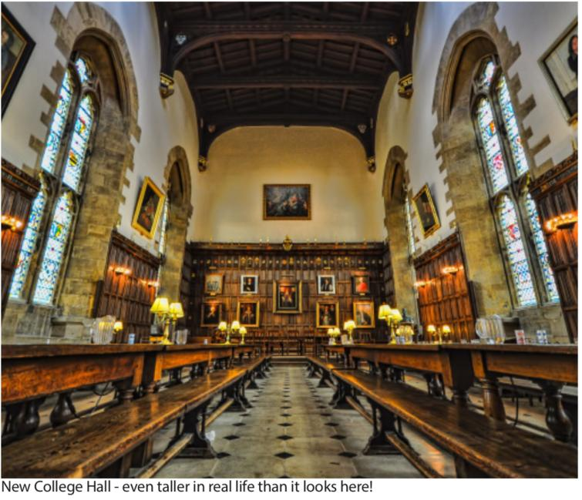
This is a front-facing image of the hall, the roof is wooden, in the center there are paintings and on either side of the image there are wooden benches and tall windows. The accompanying text reads ‘New College hall – even taller in real life than it looks here!’

Dinner (informal): 5:45-7:15pm (except on formal days when it finishes at 6:30pm). Dinner (formal): seated for 7:15 Tuesdays, Thursdays and Sundays
Formal is slightly more fancy than informal Hall; you have to wear your gown, and there is waiter service (but you don't have to get dressed up - wearing your gown over trackies is totally acceptable). You can also bring your own wine. Whether formal or informal, dinner consists of a 3-course meal.
Café/Bar
Alongside the three meals served in Hall, the bar is open from 11am-11pm, offering sandwiches, wraps and paninis, as well as a variety of snacks and hot drinks at reasonable prices. This means you can still purchase food even if you miss a mealtime. Then, in the evening the bar itself is open to serve alcohol from 6pm.
Paying for meals
Evening meals are included on battels, and you pay for any other food bought within College using your till account. All students make a pre-payment of £417.60 at the start of term. This covers all your evening meals and a fixed ‘kitchen charge’ that goes towards the kitchen staffs’ wages and the upkeep of the kitchens. Broken down this is £6.96 per meal. You can sign out of dinner if you don’t plan to go that day, up until 10am, and you will be reimbursed the cost of the meal (but not the kitchen charge), getting £4.71 back on battels at the start of the next term. Formal and informal cost the same.
Your till account is used to pay for drinks and snacks in the bar and café, and breakfast and lunch through the Buttery.
You need to keep this topped up, and again can do this through the intranet (food. new.ox.ac.uk) or at the Bursary in cash during office hours. In the Buttery, you can run into debt up to a threshold of £15, but you can’t run up a deficit in the bar or café. Any debt left on your account at the end of term is automatically added to the next term’s battels. There are fines if you exceed the debt limit.
You pay for all food using your Bod Card, which is scanned in the Buttery. In the bar you can pay by cash or credit card but beware that you lose the New College member discount, so will be charged 20% extra.
Meal booking website
The same website (food.new.ox.ac.uk) is also used to book yourself into and out of meals. Login using your bod card number. You’ll be automatically signed into informal dinner each day. Make sure to sign out when you want to and to sign on for formals if you want to go. For example, your College parent may suggest that you all go to family formal. Make sure to click cancel next to your early hall booking, and then book the sitting you want.
You can also change your preferences so you are automatically booked in for vegetarian, vegan etc. meals. Speak to Brian Cole, the catering manager (in 4OB or email brian.cole@new.ox.ac.uk) to discuss any specific dietary requirements that you have.
Guest Night
Every two weeks the JCR has a Guest Night on a Friday evening (alternating with MCR Guest Night). Our guest nights fall on even weeks. Guest Night food is particularly good, so it is a fantastic opportunity to get friends or family over, and it's always well attended. The dress code is suits and ties or cocktail dresses, and no gowns. You can get wine from the JCR wine cellar or bring your own. You sign up for Guest Night through the intranet system; be warned, tickets get snapped up very quickly. Guest Night costs £16.05 for New College Students and £19.26 for guests.
Finally, if you’re planning a birthday or a large formal hall, let Nigel in the buttery know. He can reserve you a table and will probably get you (or an unsuspecting friend if you’re surprising them) up on the mic....
FACILITIES
Laundry
The College provides us with laundry facilities. These are located in the basement of Staircase 2 in New Buildings (2NB). You need to take your Bod Card in order to get into the staircase. There are washing machines, tumble dryers, irons, and drying racks. You’ll need to provide your own laundry powder though. By the start of Freshers' week, a host of new Washing Machines and Tumble Dryers will have been installed. You'll need a credit or debit card to pay down at the laundry room. A wash costs £1.80 and a dry £0.70.
The Library
The Library is the building resembling a nuclear bunker at the end of Holywell Quad. It’s open from 8:30am until 2am, and houses most of the books you will need for your work. It also has a good selection of DVDs (non-academic) which you can borrow whenever you like. If the Library doesn’t have a book you need, there are forms in the foyer that you can use to request for the librarians order it. The Library has ample space to sit down and work. You’ll be shown how to use the Library during Fresher’s Week. Once again, it’s the Bod Card that gets you in and allows you to take out books and access your library account. You can email the library at library@new.ox.ac.uk .
The JCR
First off, note that the JCR means two things. It stands for the Junior Common Room; the community of undergrads that you’ll be joining come October. There’s also an MCR for postgrad students, and the SCR, which consists of College academic staff (like the governing body, fellows and tutors). You will find out more about the JCR, its politics,
and how to get involved later on.
Secondly, it’s a room in College, an actual common room which has been renovated in the past year. It’s got a 65" 4K TV with Sky+, PS4, Wii, Netflix, big comfy sofas, a kitchenette with free tea, coffee, milk and biscuits all term through, a vending machine, a pool table and table tennis. It’s a great social space, and available for you to use at any time, for procrastination and socialising.
IT AND COMPUTING
If you don’t have your own computer, there is a computer suite in 2NB. There are printers in the computer suite, library and JCR, which costs 7p/sheet to print, and a free scanning service. The computer suite is open 24/7. If you ever have any problems with IT, you can drop in to the IT office, in 12 OB 2 between 2 and 4 each weekday afternoon. Outside these hours, you can email the details of your problem to it-support@new.ox.ac.uk.
- Username and password combinations: A useful reference
Single sign on(SSO): Nexus email, Weblearn, the library system (SOLO), Reports (OxCort) etc:
  - Username: newcXXXX
  - Password: Initially given by College but you can change this
- Meal Booking System: Booking in and out of dinner and paying battels and tuition fees to College
  - Same as SSO
POST
Everybody has their own pigeonhole (‘pidge’) which can be found in the small room next to the Porter’s Lodge. Here you’ll receive any post sent to you from both inside and outside the University. For those wanting to send you stuff from outside, your address is ‘New College, Oxford, OX1 3BN’.
Anything that won’t fit in your pidge will be put in another room, and the porters will leave you a laminated card. You can then take this to them and swap it for your parcel.
If you want to send something to anyone within the University, intercollege post is free. Simply label an envelope with the name and the College (or Department) of the person and hand it to the porters.
For the ordinary post (unfortunately not free), there is a post-box just after the glass bit where the porters are, as you come into Holywell Quad through the lodge.

University and College Life

When you get to Oxford, you’ll be inundated with offers of things to get involved with. There are societies, clubs and teams at both College and University level. Within College
a huge variety of interests are catered for and within Oxford as a whole there is a society for just about everything. So, there’s no reason to think you’ll spend your whole life in the library!
If you’re reading this over the summer, you might want to start thinking about the sort of extra-curricular activities you might be interested in taking part in, whether it be the continuation of an existing passion, or starting something brand new. However, if you just want to look forward to the nights out to come, that’s fine too!
Entz
New College is undoubtedly among the best at having fun in Oxford; there’s always an amazing event coming up! Our bops are pretty legendary. A bop is a College-held fancy dress themed party. They’re busy, loud, great fun, and have decorations, music, drinks and costumes to match the theme. Speaking of costumes, dressing up at our bops is the norm, and everyone goes all out. There are always prizes for the best costumes, so get some body paint, capes, corsets, sparkles and wigs. Top that off with a little originality and dress to impress. Entz throughout Oxford cater for a variety of tastes. Clubs offer everything from drum and bass (the cellar) to the downright cheesy (but fabulous, Parkend), with everything in between. The Entz Officers, Charlotte Bream and Michael Nestor have organised loads to do in Fresher’s Week so you can get a proper feel for Oxford Nightlife, and throughout the year will always be organising discounted queue jump entry for all you party animals.
Image Description: This is an image of the current Entz reps, there is a person wearing a suit on the left holding another person wearing a dress on the right, with people and mirrors in the background and a champagne flute on the right. Accompanying text reads: ‘Current Entz Reps, Michael and Charlotte’
Other things to look forward to include the famous New College Boat Party, inter-year crew dates, the New College Garden Party and other events in the planning, like day trips. There are exciting opportunities for student DJs so all you talented musicians can get involved.
All this should mean that your first year is one that you’ll never forget. In addition, every 3 years New College holds a Commemoration Ball, one of the largest events that will take place during your 3 years at the University, and it is taking place this summer!

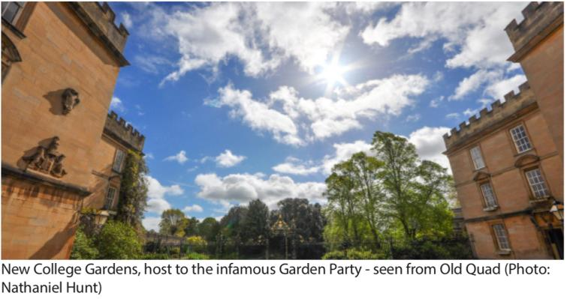
This is an image of the college gardens, the buildings take up the left and right edges, with a blue sky in the center with some clouds. There are trees along the bottom, and the gate. The mound is in the photo, obscured by trees. Accompanying text reads ‘New College Gardens, host to the infamous Garden Party – seen from Old Quad (Photo: Nathaniel Hunt)’.
STUFF YOU CAN DO IN COLLEGE
Sport
Sport is a huge part of life at New College, and whether you’re the starring striker for the Blues, or just fancy an afternoon game of croquet, the opportunities to get involved are endless. We have a fantastic sports ground just 5 minutes’ walk away from College. It has football and rugby pitches in Michaelmas and Hilary terms, and lawn tennis courts and a cricket pitch in Trinity term. There is also a squash court, and a hard court for tennis, netball and basketball. We have a lovely pavilion with changing rooms, which is perfect for watching a relaxing afternoon’s cricket in the summer. If that’s not enough we have our own set of punts which you can sign out at your leisure in Trinity term. New College Boat Club also has its own boathouse located on the Isis river, equipped with bar and balcony. As a New College student, you’ll also get free access to the Iffley Gym, about 20 mins walk from College.
At the moment, New College runs badminton, cricket, croquet, dance, darts, football, hockey, lacrosse, netball, pool, rounders, rowing, rugby, squash, table tennis, tennis, touch rugby and yoga. If you’re keen to set up something that is not on this list, notice that something has lapsed or want to organise a team, email the Sports Officer, Harrie Smith.
A large number of our teams compete in the annual inter-collegiate competition called Cuppers, and New College generally does very well. If you want to get involved, contact the captain of the team, or the Sports Rep, or alternatively, most teams should have a stall at the New College Fresher’s Fair. Don’t be put off if it seems too competitive for you - you can get involved at any level (and for those of you who want to take your sport even further, you can represent the University at most sports).
MADD
MADD stands for Music, Arts, Drama and Dance. New College is a fantastic place either to try something new or to take something with which you have experience to a new level. The first major event on New College’s MADD calendar, especially for freshers is the OUDS (Oxford University Drama Society) drama cuppers, the intercollegiate competition open exclusively to first year graduates and undergraduates. It’s a great opportunity to become closer to your fellow freshers and with no experience necessary, a brilliant way to get a feel for what an Oxford production entails!
At the heart of MADD at New College lies ‘Bryce’s Coffee House’, which are relaxed performance evenings held a few times each term. These evenings showcase everything - solo musicians, jazz groups, beat poets, comedians so if you want to give it a go just contact the Arts Officer, Maddy Page. Michaelmas also brings with it the New College Pantomime, written, directed and performed by first years in the main. You can also get involved with New College Drama Society (drop Maddy a message if you want added to the Facebook group), as well as a range of classes and workshops in College (e.g. salsa class).
New College Music Society
The New College Music Society (NCMS) is one of Oxford's leading college music societies. They offer a myriad of events and socials, and provide a wide range of activities to musicians of all abilities. They hold frequent concerts with their in-house and external ensembles, and hold free recitals every Wednesday during term-time. They also encourage college and university students to join their ensembles; their non-auditioning ones include the New College Chamber Orchestra and the Holywell Singers, while their auditioned groups include the Wykeham Consort.
In addition to their wide range of concerts and musical activities, NCMS provide many social events, which include gatherings, open mic and Jazz nights. Like and Follow their Facebook page to keep up-to-date with their many events and socials, and if you are interested in joining the successful music making at NCMS, drop them an email on newcollegemusicsociety@gmail.com.
It’s also easy to get involved in music more informally we’re proud to have our very own Band Room (get in touch with the Band Room Officer, Dominic Gray, if you’re interested)
GETTING INVOLVED
This section covers three areas that are important to life at New College, charities, access, and environment and ethics.
Charities and Environment
New College is great at getting involved in the wider community and there will be plenty of opportunities to take part in charitable activities. From working with pensioners to helping out at a community garden, there are loads of volunteering opportunities. Speak to the Charities Officer Lamis Mukta, who will be able to match you up to a volunteering opportunity in Oxford that fits you.
Within College, we raise thousands of pounds each year for charity, voting on the charities this money goes to in the JCR each term. There is an optional battels levy, which contributes to this fund. There are also various college events such as charity formal hall that help raise money. On top of this there are also fundraisers in College, for example, the Oxford Half Marathon in October. We create a New College Naked Calendar each year, and are always looking for new ideas to raise money. If you are interested in running an event contact the Charities Officer, Lamis Mukta.
You can also get involved with helping with environment and ethics. We have been involved with the Living Below The Line Campaign, where students pledge to make an effort to live on just £1 a day for a week in order to raise money and raise awareness for charities working to fight poverty across the globe. In addition to this, we have looked into the possibility of donating spare food from Hall to The Gatehouse. Contact Caitlin Knights if you're interested in making New College more environmentally friendly!
Access
Last but by no means least, access is really important at New College, and it’s something that you can get involved in, making a real difference to prospective students who, through being inspired by you, make a decision to apply to Oxford when they might not have done otherwise. It’s all about encouraging everyone to apply, irrespective of their backgrounds. The main way that we do this is through visiting state schools or having them visit us. This relies on volunteers and the Access and Outreach Officer, Chloe Manuel, will be in touch to recruit willing tour guides each week. In addition, there is an ambassador scheme, where volunteers are trained and are involved in access work on a more consistent basis. Besides visits, we have our Facebook page 'New: Over The Wall' featuring stories and testimonials from students at the College, so get liking and sharing! Find us on Instagram @newcollegeaccess.
Typically, volunteering means giving a tour of College, having some (free) lunch and giving a Q and A session about Oxford. It’s encouraged for everyone to get involved in access events, no matter what background you’ve come from - remember that the entire point of access is that your school doesn’t matter.
One of the most well-known University-wide schemes is called Target Schools, which encourage Oxford students to visit state schools in their local areas. If this is something you wish to get involved in you can get training and support. They also run a programme in which prospective students “shadow” a current student in a subject they’re interested in, attending lectures and seminars for a day.
STUFF OUTSIDE OF COLLEGE
There are so many societies in Oxford that to start a list would be impossible. You’ll find out about all these at the Oxford SU's Freshers' Fair. This takes place in Freshers' Week in Exam Schools. There are tables representing everything from skiing to Amnesty International, from the Biochemistry Society to J.R.R. Tolkien Appreciation.
One important organisation at a University level is Raise and Give (RAG), which gives you the opportunity to do anything from bungee jumping to hitchhiking all in the name of charity. They also organise infamous club nights and other social events. Look for them at the Freshers’ Fair and their own RAG Freshers’ Fair.
Oxford SU
Oxford SU is the Oxford University Student Union. Because of the College system, it isn’t a social hub like at some other universities but it still does important work. Oxford SU Council is every two weeks and New College is invited to send three representatives to vote on issues like endorsing NUS regulations or SU Policy. We send the Vice President for Communications, Welfare and Equality and the President, but there is one space up for grabs, so you could make a difference just by turning up. The Freshers’ Fair is run by Oxford SU too.
The JCR
If you’ve read everything so far, firstly well done on sticking with it! Secondly, you might have noticed mentions of people like the Entz Officers, or the Sports or Arts Officers, and you might be wondering who they are.
Each Trinity term the JCR elects a committee, led by the President, which works to run various important things around College, and to allocate JCR funding.
Image Description: There is an image of the JCR committee sat on the stairs outside hall, with a wooden door on the left. Accompanying text reads ‘Your JCR Comittee’
Absolutely everyone has a say in the running of the JCR – through JCR meetings and motions anyone can put forward a proposal for how to spend our budget, or a policy the JCR should adopt, or a new idea we should explore - all which is voted on.
JCR money is spent on the likes of sports kit, arts, big college socials, bagatelle boards, pizza, and any other items that get JCR approval. The VP for Finance and Operations ensures that we remain within budget.
To get your hands on this cash, simply put in a motion to the Vice President for Communications, Welfare and Equality, Phoebe Tuckett, and turn up to the JCR meeting to make your case.
JCR meetings are your fortnightly dose of democracy, with large quantities of pizza on the side. At these meetings, we decide our spending as well as our affiliations. However, New College is not the most political of colleges so we don’t make as many big political statements as some other colleges (in fact, we’re pretty apathetic about most things, in a benign and friendly way). There will be a taster session for JCR meetings in the Freshers' Marquee on Sunday evening, where you’ll see how JCR meetings run.

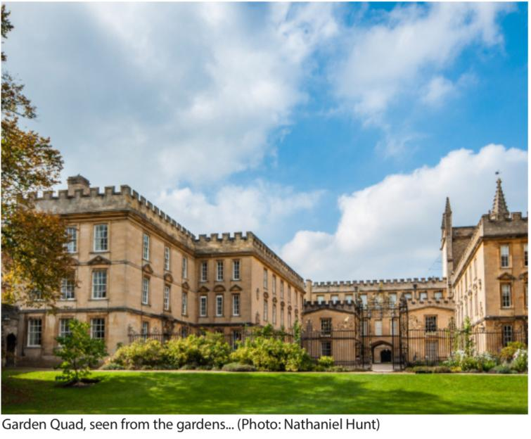
Image Description: This is a picture of garden quad, with grass at the bottom, the buildings taking up the middle of the photo and a blue sky above. The accompanying text reads ‘Garden Quad, seen from the gardens… (Photo: Nathanial Hunt)’

The JCR Committee – Executive

Image Description: There is a photograph of Kendya Goodman, wearing a blue shirt in the cloisters.
President - Kendya Goodman
Email: kendya.goodman@new.ox.ac.uk
Pronouns: She/Her
Bio: Hi everyone, my name is Kendya, I'm a second year HistPol student, and your JCR President for this year. First of all - congratulations for getting into Oxford! What you've already accomplished so far is phenomenal, and you are very welcome to our community at New College. Thank you for choosing New College, we are very lucky to have you all here, and as your President I hope to help you all get the most out of your time here at Oxford. Our JCR committee is fantastic and very committed to this wonderful college that you will soon call home. My job is to co-ordinate the team, with the help of our two VPs and to ensure that we are all fulfilling our elected responsibilities and enriching college in any way we can.
If you have any suggestions for improvements you would like to make to College, I'd love to hear them, and we will ensure that it is easy for everyone in college to express their opinion to us - I'll be representing your views to College, the University and Oxford SU. We are very committed to ensuring that college provides for everyone within the community, and that we are meeting the needs of all as much as we can. Most of all, I want to welcome you into this community, as you'll soon learn it's a happy one. Enjoy your summer, and I look forward to meeting you all in October!
If you have any concerns or questions before then, shoot me an email or message me on Facebook.
Image Description: There is a photograph of Phoebe Tuckett in the cloisters, wearing a black pinafore and a striped shirt.
Vice-President for Communications, Welfare and Equality - Phoebe Tuckett
Email: phoebe.tuckett@new.ox.ac.uk
Pronouns: She/Her
Bio: Hi everyone! I'm Phoebe, a second year PPEist, and I will be Vice President for Communications, Welfare and Equality this year. This role is new to the JCR, so very open to interpretation! It basically involves coordinating the welfare and diversity side of the JCR - organising projects, and making sure your views are fairly expressed - whether that be in JCR meetings or at the Student Union. Most importantly, if you need any support, or if you think your life at New College could be improved in any way, I'm here to help. Looking forward to meeting you all in October, enjoy the rest of your summer, and if you have any questions before or after term starts, please feel free to message me on Facebook or drop me an email.

Image Description: There is a photograph of Sarah Platts in the cloisters wearing a gray turtleneck and a heart necklace.
Vice President for Operations and Finance - Sarah Platts
Email: sarah.platts@new.ox.ac.uk
Pronouns: She/Her
Bio: Hey guys, I’m Sarah, a second-year lawyer and I’ll be your Vice-Pres- ident for Operations and Finance for the coming year, responsible for maintaining the financial records of the JCR, much like a treasurer. I help with the day-to-day administration of financial matters and to ensure that our generous budget is readily accessible to every member of the JCR through budget motions to be voted on at JCR meetings. Another responsibility is chairing the Finance and Operations Team to make sure that your first-year experience is as enriching and fun as it possibly can be by helping the team organise and provide events and trying to encourage all the freshers to get involved and also voice any questions you may have. We have one of the most generous JCR budgets of all the colleges, so funding is available for all sorts of exciting things, whether it be sports, MADD, Entz, welfare, charities, academia – anything really, so if there are any ideas for new ventures, they are most welcome and can hopefully happen to ensure there is a wide array of events and opportunities to look forward to throughout the coming year. I look forward to hopefully meeting most of you at the many exciting events we have arranged in Freshers Week and in the meantime, if you have any questions relating to the JCR or finances in general, please don’t hesitate to get in touch with me – I’ll be more than happy to help!
Image Description: There is a photograph of Lizzie Crawford, in the cloisters, wearing a beige top
Welfare Officer (Women and Transfeminine) - Lizzie Crawford
Email: lizzie.crawford@new.ox.ac.uk
Pronouns: She/Her
Bio: Hi! I'm Lizzie, and Jordan and I are your welfare reps for
this year! This means that we'll be around to chat to you about anything at all that might be worrying you. We'll be getting peer support trained to help us provide the best support possible! We'll also be putting on lots of events throughout term, such
as weekly welfare teas, where you can come and get lots of free food. Every week in term time, Jordan or I will send out an email to keep you updated with all things welfare, so keep an eye out for this too! If there's ever anything you'd like to chat about, including before you arrive, please feel free to send me an email. Looking forward meeting you all!
Image Description: There is a photograph of Jordan Yang in the cloisters, with a tree on the left, wearing a purple New College Freshers’ T-Shirt
Welfare Officer (Men, Transmasculine and Minority gender) - Jordan Yang
Email: jordan.yang@new.ox.ac.uk
Pronouns: He/Him
Bio: Hi, I’m Jordan, one of your friendly neighbourhood welfare officers. Lizzie and I are about to help you out with concerns and problems you encounter throughout the year. We’re going to be peer support trained throughout the year, which means we’ll be learning as much as we can to help you with any problems you have. We’ll be organising JCR teas throughout the year as well as working with other officers to organise activities to give you a break from the stresses life may throw at you. Look out for weekly welfare mail from me or Lizzie detailing welfare events happening throughout the week. I look forward to meeting all you guys!

Image Description: There is a photograph of Hannah Belok, in the gardens, wearing a mustard yellow sweatshirt.
Women’*s Officer - Hannah Belok
Email: hannah.belok@new.ox.ac.uk
Pronouns: She/Her
Bio: Hi, and welcome to New College! I’m Hannah and I’m a second-year mathematician. I’m also the Women’s Officer for this year, which means I represent anyone and everyone who identifies as a woman, and ensure your time here is as safe and inclusive as possible. I’ll be hosting a variety of events throughout the year, including weekly discussion groups and panels with interesting speakers – please note that these are open to everyone, including those who don’t identify as female. Please don’t hesitate to say hi or drop me a message at any point during the week or throughout the year. I hope you all enjoy the rest of your summers and I look forward to meeting you all in October!
Image Description: There is a photograph of Chloe Manuel in the cloisters, with a bush behind her, wearing a striped shirt
Access and Outreach Officer - Chloe Manuel
Email: chloe.manuel@new.ox.ac.uk
Pronouns: She/Her
Bio: Hi, I’m Chloe, a second-year English student and your Access and Outreach Officer this year! My role has two aspects: to work towards a more diverse and representative student population at New College, and to ensure that everyone feels at home whilst they are here. My responsibilities include leading Q and As and tours around college for prospective students,
as well as getting involved in University-wide access schemes, everything from tutoring in local comprehensives to hosting Oxford’s summer schools. I also run our social media project New: Over the Wall, with which we aim to provide you with a candid and honest insight into life here at New College, while hopefully dispelling some Oxford myths to make you feel more comfortable. Anyone from any background can get involved
in access work, so if you’re interested in what I do I’ll be around during Freshers’ week so feel free to come and say hi, and as always, you’re welcome to get in touch with me with any questions or ideas about access!

Image Description: There is a photograph of Anish Khanna by the gate in the garden, wearing a Levi’s T-Shirt.
Ethnic Minorities Officer - Anish Khanna
Email: anish.khanna@new.ox.ac.uk
Pronouns: He/Him
Bio: Hey everyone, I'm Anish, a second-year lawyer, and your Ethnic Minorities Officer for this year. My role as Ethnic Minorities Officer is to ensure that the views and needs of all ethnic minority students are heard. I'll be hosting regular socials throughout the year so that the BME community within college can get to know each other even better. There will also be lots of events within College that I'll be organising to celebrate everyone's respective culture, and I'll be promoting other fun and social events around the whole University. As part of the welfare team, I will become a trained Peer Supporter. This means that I will be here to support anyone who may need a listening ear, not just ethnic minority students. I look forward to seeing you all very soon!

Image Description: There is a photograph of Tiger Brown in the cloisters, wearing a lime green shirt on top of a black T-Shirt.
LGTBQ+ Officer - Tiger Brown
Email: tiger.brown@new.ox.ac.uk
Pronouns: He/Him
Bio: Hello, I'm Tiger and I'm a 3rd year psychology and philosophy student. As your LGBTQ+ rep, I’ve got a wicked line-up of activities, from movie nights to picnics to drinks nights, so everyone can have good clean fun. Some will be queer-only and some queer-friendly but open to everyone. There are lots of University-wide activities
too, including Tuesgay drinks (haha) every Tuesday and Glitterball, Oxford's queer ball, which I'll keep you posted on through LGBTQ+ emails and our Facebook group. I'm also here to help for any LGBTQ+ concerns, whether private or to do with college. New College is very LGBTQ+ friendly and I can't wait to meet you all!

Image Description: There is a photograph of Ebie Edwards Cole wearing a black jacket on top of a red t-shirt.
Disabilities Officer - Ebie Edwards Cole
Email: ebie.edwardscole@new.ox.ac.uk
Pronouns: She/Her
Bio: Hi - my name is Ebie. I'm a second year PPE student and I'm the JCR Disabilities Officer this year. My role involves voicing the concerns and fighting for the needs of students with disabilities (including those with mental health conditions) at New College and providing support for students with disabilities during their time at Oxford. I am a member of the Executive Committee for OSDC (Oxford Students' Disabilities Community) so if you have any questions about social events for students with disabilities, just ask! Managing a disability (or disabilities) at Oxford can sometimes be really challenging, and if you ever need to chat, or need some help to navigate the inter-collegiate system to work out who you need to talk to about something, feel free to drop me an email or a message on Facebook (even before you get here!) and I'll do my best to help.

Image Description: There is a photograph of Ailidh Finlayson in the cloisters wearing a maroon shirt, a black and white patterned sweater and blue jeans
International and Overseas Officer - Ailidh Finlayson
Emails: ailidh.finlayson@new.ox.ac.uk
Pronouns: She/Her
Bio: Hi, my name is Ailidh. I’m a second year from California studying Experimental Psychology, and I’ll be the international students officer this year. My role as international student’s officer is to make the transition into university as smooth
as possible for international students and to plan events for international students throughout the year. When you arrive at New College, I’ll be there to welcome you, and I'll arrange activities so you have opportunities to meet other international students and settle into New College before the domestic students move in. In addition to activities in College, the University runs an international orientation (make sure to register online for this) which will give you the information you need to sign up for healthcare, open a bank account, etc. If you have any questions about coming to Oxford, I’m more than happy to answer them either by email or find me in person at any point in Freshers Week. I look forward to meeting you all!

Image Description: There is a photograph of Rohan Bhatia in front of the garden gate wearing a blue shirt.
Food and Bar Officer - Rohan Bhatia
Email: rohan.bhatia@new.ox.ac.uk
Pronouns: He/Him
Bio: Hey guys, I’m Rohan a second-year linguist and I’ll be your food and bar rep next year. Just to make clear, I don’t always dress like a waiter, however, I’ll do what I can to help you guys out if you have any food or bar related inquiries. Be that because you have special requirements or even if you just think the food is grim, either way I’m your man. The bar is a fantastic social space and is close to the heart of many New College members, so make sure you make the most of it, it all kicks off with the bar quiz in fresher’s week. See you there
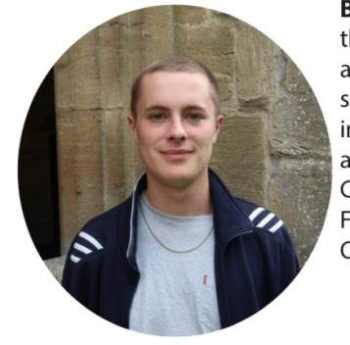
Image Description: There is a photograph of Harrie Smith wearing a navy blue jacket with a gray t-shirt underneath in the cloisters
Sport Officer - Harrie Smith
Email: harrie.smith@new.ox.ac.uk
Pronouns: He/Him
Bio: I’m Harrie, a second year PPEist, and I’ll be your sports officer for the year ahead. There are huge sporting opportunities available both at college and university level. Sports at New College is varied and successful and everyone, regardless of ability, is welcome. Taking part in College sport is a great way to meet people across the year groups and throughout College. Funding is available both to set up New College sports and to support those competing at a university level. Feel free to drop me an email if you have any questions. See you in October!
Image Description: There is a photograph of Anna Wilson in the cloisters wearing a navy blue Oxford Belles sweatshirt.
Academic Affairs Officer - Anna Wilson
Email: anna.wilson@new.ox.ac.uk
Pronouns: She/Her
Bio: Hi, I’m Anna. I’m a second year English and French student, and I’ll be your Academic Affairs representative this year. New College has many support networks in place to help you cope with the academic challenge of studying at Oxford, and to ensure that you can meet your full potential and get the most out of your time here. These include your tutor, college family and subject representatives. Alternatively, I am always happy to sit down with you for a chat if you are having problems with your course or general study habits. My role also involves working alongside college on Interviews and Open Days, as well as dealing with workspaces and tutor feedback. During Freshers’ Week, I’ll be putting together a ‘Who’s Who’ guide to help you get familiar with all the new faces – hopefully I’ll get the chance to meet many of you then. Please feel free to drop me an email if you have any questions or concerns
Image Description: There is a photograph of Maddy Page, wearing a patterned short-sleeved shirt on top of a gray shirt, in the cloisters.
Arts Officer – Maddy Page
Email: maddy.page@new.ox.ac.uk
Pronouns: She/Her
Bio: Hi guys, I’m MADDy, I’m a second year PPEist and MADD (Arts Officer) for this year. What does that mean, you might ask? Aside from giving me a really corny campaign slogan, it stands for Music, Art, Dance and Drama, so if you’re remotely interested in any of these, please feel free to get in touch. A few one-offs such as the New College Panto and our Arts Week are worth looking forward
to, as well as a host of workshops and classes across the year. From salsa to film screenings, kitting out your room with pieces from the Art Store or getting involved in some open mic nights, I’m sure you’ll hear from me pushing various events on the JCR Facebook page, but before then I hope to see a few of you at the MADD Freshers Evening on Saturday 6th October. I look forward to meeting you!

Image Description: There is a photograph of Charlotte and Michael, back to back in the gardens.
Entz Officers - Charlotte Bream and Michael Nestor
Emails: charlotte.bream@new.ox.ac.uk / michael.nestor@new.ox.ac.uk
Pronouns: She/Her (Charlotte) and He/Him (Michael)
Bio: Hey guys! We’re Charlotte and Michael, and we’re your Entz Reps for this year. Our job is to make sure your time at New College is as fun as it could possibly be all year round. In Freshers’ Week, there will be lots of fun events to introduce you to the nightlife of Oxford (it’s not as bad as you may think – promise!). We also put on an equally amazing variety of non- alcoholic events. Throughout the year, we’ll be in charge of putting on more events in and out of College, such as the Garden Party and Boat Party, as well as organising the best bops around. Feel free to get in contact with either of us if you want to know more about things that are going on.
Image Description: There is a photograph of Sam Krasner, in the cloisters, wearing a pink shirt
Housing and Facilities Officer - Sam Krasner
Email: sam.krasner@new.ox.ac.uk
Pronouns: He/Him
Bio: Hello! My name is Sam and I’m a second-year medic. I am your Housing and Facilities Officer for the year ahead and I will look after all things related to student accommodation within college. New College will soon become your home for the next 3 or 4 years (or 6 if you’re as lucky as me!) so it is important to make sure you are as happy and comfortable as possible.
I am here to help with any issues concerning rooms, kitchens, the laundry service, booking guest rooms, vacation residence and the JCR Common Room. Feel free to contact me before you arrive in October if you have any questions about your room and what you should bring (e.g. finding out the size of your bed). I look forward to meeting you all soon!
Image Description: There is a photograph of Lamis Mukta, in the cloisters, wearing a black bardot top.
Charities Officer – Lamis Mukta
Emails: lamisah.mukta@new.ox.ac.uk
Pronouns: She/Her
Bio: Hi I’m Lamis, a second-year maths student, and your new charities officer. Firstly, congratulations on making your offers and welcome to New College! I’m in charge of running all the charitable events, fundraising, and volunteering this year. This will include organising events - like a summer fete, the naked calendar, and charity formals - all in support of charities we will choose as a college. I’m particularly interested in setting up a leftover food distribution scheme for homeless people. I’ll also be going to University wide meetings to find out about volunteering and charity opportunities outside of college and designing and sell some charity college “stash” (what we call oxford/ college branded stuff ). As a college, we have so much potential to help others and so I want to make the most of it!
Image Description: There is a photograph of Caitlin Knights, in the cloisters, wearing a maroon long-sleeved top.
Environment and Ethics Officer - Caitlin Knights
Emails: caitlin.knights@new.ox.ac.uk
Pronouns: She/Her
Bio: Hi, I’m Caitlin, a second year PPE-ist and your Environment and Ethics Rep for this year. The main emphasis of this role is on the environment - from making sure recycling in college operates smoothly to investigating ways to reduce energy usage and waste. I also hope to magnify your ethical concerns; holding the college to account on issues such as ethical investment. Furthermore, I will keep you all updated on college and university campaigns. If you have any ideas for how New College can be a more environmentally sustainable place or would like to be involved in any environmental or ethical campaign, I would love to hear from you! Also, if you are just angry about something which is E&E -related, my door will always be open for a cup of tea and a rant!
Image Description: There is a photograph of Ria Sangal in the cloisters, wearing an orange bardot top.
JCR Officer – Ria Sangal
Emails: ria.sangal@new.ox.ac.uk
Pronouns: She/Her
Bio: My name’s Ria, I’m a second-year lawyer and this year I’ll be your JCR Officer. JCR stands for ‘Junior Common Room’ and is a place where people can go to play pool, table tennis , FIFA or Fortnite. There’s also a kitchenette which you can use to make tea and heat up your food. I’ll make sure there is a steady supply of tea, coffee and biscuits there throughout the year. As your JCR Officer, it’s my job to make sure that it’s a place where you can unwind and relax, and to make college feel more like home for you. Can’t wait to meet you all in October!

The JCR Committee – Non-Executive

IT Officer - Ollie Turnbull
Pronouns: He/Him
Bio: I’m Ollie, this year’s IT officer for the JCR. I’m here to help with any problems with college’s IT facilities that you may have. I’m also in charge of running the JCR website and freshening up its design. So, feel free to get in touch with anything IT related, whether its problems with getting online or info on the various computing courses offered around the university!
Image Description: There is a photograph of a band on a stage, each with different instruments and there are blue lights behind them. The accompanying text reads ‘New College Big Band, AKA Green Bean Machine, performing at the Ball 2 years ago.
Band Room Officer - Dominic Gray
Pronouns: He/Him
Bio: Hi! I am your Band Room Officer and my role is to help you make the most of one of the practice rooms in college. The band room is beneath the JCR and has a drum kit, keyboards, guitars, amps, microphones and music stands – it can be booked by asking the porters at the lodge and is one of the few practice rooms that can be booked in advance. If you are organising an event, be it inside or outside of college, you can borrow equipment from the band room by getting in contact with me. At the beginning of term, I'm going to be looking into what equipment needs to be replaced and what else we need to purchase, so if you have any suggestions, please let me know!
Wine Stewards - Amelia Hart and James Dayman
Pronouns: She/Her (Amelia) and He/Him (James)
Bio: Hi, we are this year’s wine stewards - come and visit us in the only student-run wine cellar in Oxford to pick up a bottle from our range! We aim to provide good quality wines at all price points, and whilst the Old-World classics of France and Spain will continue to be well represented, we will be looking to introduce newer and more unusual offerings for you to try. James is a second-year PPE student, and Amelia is a second-year historian; both of us have a love of all things vinous so do not hesitate to approach us for top-drawer wine chat, advice or any special requests. In addition to opening the cellar several nights a week before formal, we will be hosting wine-related events throughout the year, starting with a classic ‘wine and cheese’ night in Michaelmas. Make sure to drop in to the cellar before family formal at the end of Freshers’ week!
Image Description: There is a photograph of a person wearing a jacket with his arm around a person wearing a black top. There are houses in the background and another person on the right at a different table. The accompanying text reads ‘Wine Stewards!’
Bike Rep - Samuel Luxa
Pronouns: He/Him
Bio: Hiya guys, I’m Sam, JCR Bike Officer! The JCR has a small number of bikes which are free for you to borrow, and it’s my job make that happen. So, whether you need to race between classes on opposite sides of town or just fancy getting out and about, don’t hesitate to get in touch! Also feel free to drop me a message for any tips about where to buy, fix, or ride a bike in and around Oxford.

Image Description: There is a photograph of a golden liquid in a glass with mint and a black straw on a white table. The accompanying text reads ‘The humble Mint Julep’
Mint Julep Quarterperson - Sasha Lloyd-Briscoe
Pronouns: She/Her
Bio: My name is Sasha, and I’m the Mint Julep Quarter-person for 2018-19. The position of Quarter Person is unique to New College, and will probably require a bit of explanation to those who aren’t savvy with our fascinating history. On a visit in 1845 William Trapier, a wealthy businessman from Charleston, SC, asked for a Mint Julep – a type of cocktail containing mint, bourbon whisky and sugar popular in his part of the States. Realising that nobody had heard of the drink, he made his own from ingredients lying around the college, and left his recipe, a personal drinking cup and a sum of money
for the provision of Mint Juleps on the 1st of June every year. The job of the Quarter person is to provide students of the college with Mint Juleps (as well as other, equally attractive non-alcoholic choices, of course) on this very special day, and to (hopefully) keep the tradition alive for years to come.
New College Cookie Fairy
Email: elizabeth.crawford@new.ox.ac.uk / jordan.yang@new.ox.ac.uk
Hi, I'm the New College Cookie Fairy! If you feel anyone you know (including yourself ) could use a baked treat in their pidge (like their letter box in college), let me know and I'll get a cookie to them! You can get in touch by emailing Lizzie or Jordan or by messaging me on Facebook - my name is New-College Cookie-Fairy. See you all soon!

Other Aspects of College Life

Welfare
Whilst we don’t want to scare you, and suggest that you’ve got any reason to panic, moving to university is a huge change. Adjusting to living by yourself, perhaps for the first time, to being more independent, or having a larger workload can sometimes be hard.
You might find it reassuring to know that for many people Freshers' Week is by no means the best week of their Oxford experience, or even close, and many people take some time to get used to it.
If you do find yourself needing some support, in Freshers' week or beyond, there are loads of places you can go and people you can talk to.
We have a welfare system that is fantastically run by the Welfare Officer, Lizzie Crawford and Jordan Yang. Speak to any of the JCR welfare team (which includes the Welfare Reps, the LGBTQ+ Rep, the BME officer, the Disabilities officer and the Peer Supporters), who are always willing to have a chat if anything is bothering you; they’re trained in how to do this. Alternatively, there are services such as Oxford Nightline or the Oxford University Counselling service that you can get in contact with.
We also have the great resource of the Cox and Salvesen fellows. They live in College, and are there to help with student’s welfare. They are the people to contact if you have concerns before you get to College, for example, existing health conditions. More about them later in the section on College staff and other important people.
Some useful welfare contacts are:
University Welfare (information on services available as well as useful advice and tips): www.admin.ox.ac.uk/shw/
Oxford SU have a similar website: www.oxfordsu.org/wellbeingwww.oxfordsu.org/well-being

Image Description: There is a photograph of a bunch of snacks on a table, including doritos, some tea and grapes. The accompanying text reads ‘The ingredients of a JCR welfare tea, regularly held by the Welfare Reps’
LGBTQ+
New College is known for its accepting, jovial atmosphere. As such, it is an awesome place to feel comfortable identifying as LGBTQ+. The JCR’s LGBTQ+ Officer, Tiger Brown, has the responsibility as part of the welfare team to make sure everyone feels welcome and happy at New College, particularly those who are not part of
the cis/het community, and ensure that everyone in the JCR is fairly represented in College. The LGBTQ+ Officer is also responsible for organising events such as drinks, crew dates and dinners in Hall to raise money for LGBTQ+ focussed charities. If you have any concerns even remotely related to being LGBTQ+ in College you can chat to Tiger. There are also Rainbow Peers across the University, who are trained Peer Supporters there to offer support to LGBTQ+ students across all colleges and throughout the wider University. (For more information, email rainbowpeers@admin.ox.ac.uk.)
In Oxford, tolerance is the norm. There are thousands of supportive members of the wider Oxford student body. The LGBTQ+ scene
is well established and as such, there are a few places for a great night out. Babylove is Oxford’s gay pub and is a great place to stop and have a pint any day of the week. Every Tuesday evening the Uni-wide LGBTQ+ society hosts LGBTQ+ drinks at a different college bar. After a couple of hours there, those who fancy staying out a bit longer end up inevitably at Babylove to keep the night going
for Tuesday night ‘Poptarts’
which always has legendary conclusions. Plush, Oxford’s gay nightclub has two big nights on Friday and Saturday, which are great if you are in the mood for some really catchy music! No doubt you’ll be singing it for days.
Some useful contacts:
For more information about the LGBTQ+ society in Oxford, visit www.oulgbtsoc.org.uk.
Image Description: There is a blurry photograph of New Buildings with the rainbow flag flying above the buildings. The accompanying text reads ‘New College flies the rainbow flag for LGBTQ history month
Stonewall is a lesbian, gay and bisexual charity, which has a hotline for anyone needing support: 08000 502020.

New College flies the rainbow flag for LGBTQ history month
Faith at New College
University is a time for discovering new things. This can include further exploring your own religion, learning about other ones and meeting new people in religious communities (both inside and outside of College). It goes without saying that Oxford aims to be welcoming to everyone, regardless of faith, and that one of the most exciting things about going to university is being in such a diverse environment, whilst also finding your own niche.
New College has people of many different faiths, who would be willing to talk to you if you have questions or need support. Some of them are involved in University wide societies
of faith, all of which are friendly, welcoming communities. A few examples include Oxford Inter-collegiate Christian Union (OICCU), Islamic society (ISOC), Jewish Society (Oxford JSOC), Hindu society (HUM) among many others. Often, communities of faith can take on a welfare role and act as support networks, giving many people a place where they feel they belong. Getting involved can also lead to unexpected discoveries by giving you a chance to explore something you may have taken for granted.
In terms of religious communities within College, there is a Christian Union, run by Anna Houchen. The Christian Union is a nondenominational community meeting every week
to chat, eat cake, read the Bible and pray. There are also many university-wide CU events, including lunchtime talks, relaxed discussion group ‘The Search’, and pub socials. You can sign up for the freshers’ residential 19th - 21st September, an amazing opportunity to make friends before term starts (www.oiccu.org/freshaway). Send us an email at christian.union@new.ox.ac.uk if you have any questions, particularly if you’re looking for a church in Oxford.
The Chapel also plays an important role at New College, being a place of reflection, worship and regular services sung by our world-renowned choir (Evensong at 6.15pm everyday apart from Wednesday; Eucharist on Thursday).
Our Chaplain, Reverend Dr Erica Longfellow (erica.longfellow@new.ox.ac.uk) is very friendly and approachable, and organises morning prayer (plus free breakfast), discussions over lunch every week (‘Soul Food’), Christmas tree decorating... amongst many other things. See the chapel term card or contact the chaplain for details . The Chaplain is very happy to support the welfare of students and always willing to see members of College on any issue, or simply for a chat, whatever their belief or faith background.
The Chaplain and the Assistant Chaplain, Rev Susan Bridge (susan.bridge@new.ox.ac.uk) are both based in 3OB6.
Some useful links and contacts:
OICCU: http://www.oiccu.org/
OUISOC: http://ouisoc.org/
Oxford JSOC : http://www.oxfordjsoc.co.uk/jsoc/
Hindu society: http://www.oxfordhumsoc.com/
A far more comprehensive list is available on the University of Oxford website, under ‘Religion and Belief’ at: https://www.admin.ox.ac.uk/eop/religionandbelief/faithsocietiesgroupsor-religiouscentres/#d.en.31129

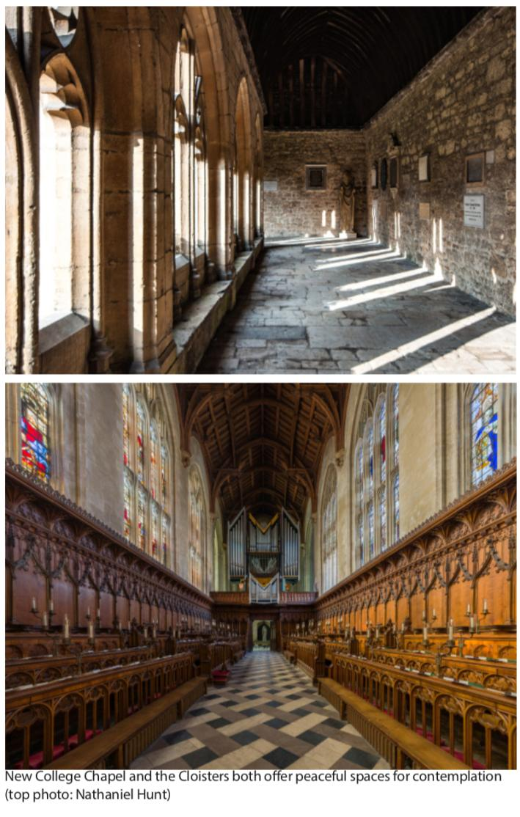
There are two photographs, one on top of the other. The top picture shows the cloisters, with sunlight coming into the stone passage. The bottom picture shows the chapel, facing the organ, with a wooden roof and wooden pews on either side. The accompanying text reads ‘New College Chapel and the Cloisters offer peaceful spaces for contemplation (top photo: Nathaniel Hunt)’

College Staff and Other Important People

These are the people you really want to keep happy. It’s especially worth getting to know the scouts, porters and catering staff, who are the key to the college. You will find that they are lovely people and you won’t find it difficult to stay on the right side of them!
Image Description: There is a photograph of Miles Young, wearing a dark tweed jacket, a blue shirt and a blue tie in front of a bookshelf. The accompanying text reads ‘Photo - ©John Cairns’
Miles Young, Warden.
The Warden is the head of the College and the most senior figure of authority. You’ll probably meet him to go through your reports.
Image Description: There is a photograph of Michael Burden wearing a blue checked shirt in front of a dark greenish-gray wall. The accompanying text reads ‘Photo ©John Cairns’
Prof Michael Burden, Dean
The Dean is in charge of discipline in College. You can arrange to see him through his secretary, Jacqui Julier (jacqui.julier@new.ox.ac.uk) but otherwise you’ll only bump into him if you’ve committed a serious misdemeanour.
Image Description: There is a photograph of Erica Longfellow wearing dark clothes and a dog collar in front of the niche of reredos. The accompanying text reads ‘Photo - ©John Cairns’
Rev Dr Erica Longfellow, Chaplain
Erica is a Church of England Priest and is responsible for services in the Chapel. She is available to listen to any member of College regardless of spiritual background.
Image Description: There is a photograph of Gez Wells wearing a suit with a white and blue checked shirt and black tie.
Mr Gez Wells, Home Bursar
Gez is in charge of most of the non-academic operational sides of college life - accommodation, domestic, catering, security etc. You can call for a chat with him if you have any questions!
Dr Mark Griffith, Senior tutor
Mark has overall responsibility for undergraduate teaching and academic matters in the college.
Image Description: There is a photograph of David Palfreyman wearing a navy suit, with a pink shirt and navy blue dotted tie. The accompanying text reads ‘Photo - ©Sasha Snow’
Mr David Palfreyman, Bursar
David is the man with the money. Should you ever come into financial difficulty, or need to talk about grants and loans, arrange an appointment through his secretary in 4OB1.
Image Description: There is a photograph of Daniel Harkin wearing a gray suit and a blue shirt in front of a stone wall.
Daniel Harkin, Salvesen Fellow, Cox Fellow (Appointed in September)
Hello, I'm Dan, the Salvesen Fellow and in September, I'll be joined by a new Cox Fellow. Together, we’re senior members of the College and part of the Welfare Team. We live on site and we are available to meet with students about any aspect of life and study in College and in Oxford. To arrange a meeting with us, just pop an email to daniel.harkin@new.ox.ac.uk. We can also be contacted in emergencies via the lodge. Part of our job is building bridges between the JCR and the SCR, so you’ll find that we host regular events, including some of the introductory sessions during Freshers’ Week, and an event for new students during Michaelmas Term.
Image Description: There is a photograph of around 45 people on the grass of Holywell Quad, all in navy blue except a woman in red in the background and a woman in blue and white to the right of the cluster of people. Accompanying text reads ‘New College Scouts assembled on Holywell Quad’
Scouts
These lovely people are in charge of cleaning the rooms of the inevitably hungover/messy/ still asleep undergrads. They’ll come in once a week, which means you’ll have to get out of bed before noon at least once a week if you want your room cleaned (probably a good idea). They are generally chirpy and very nice.
Image Description: There is a photograph of Howard Weller smiling
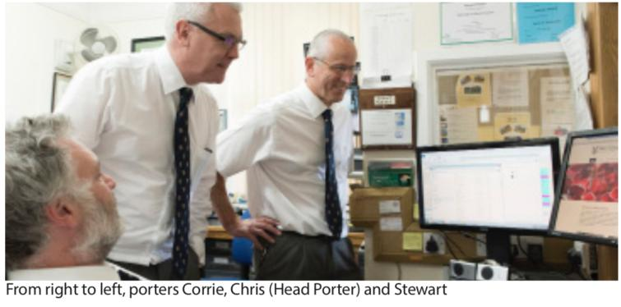
Image Description: There is a photograph of three men, two standing and one sat, looking at two screens in a cluttered office. They are wearing white shirts and navy blue ties. The accompanying text reads ‘From right to left, porters Corrie, Chris (Head Porter), and Stewart’
Porters
These people are the engine room of College. They staff
the Porters Lodge at the Holywell entrance and know everything that’s going on in College. They’ll be the ones who shut down raucous parties but they’re also incredibly helpful, and we’re lucky to have such a good-humoured and friendly bunch. They’ll be there 24 hours a day so if you ever need to know anything about College or get your key, pop into the Lodge.
Maintenance
Despite testing fire alarms at 9am, the maintenance team are there to be helpful! If you ever need something fixing (broken showers, electricity gone, etc.) you can put in a maintenance request. Google New College maintenance request, and once you’ve proved you’re not a robot they’ll be able to send someone to fix your leaky shower or broken drawer handles.
Image Description: There is a photograph of Michael Collett in the cloisters wearing a blue shirt, the accompanying text reads ‘Michael Collett, Clerk of Works´
Kitchen Staff
These wonderful people prepare and serve the meals you enjoy in Hall. There are some real characters among them, including the enfant terrible, Nigel Ewers, who is fond of hijacking the microphone in Hall like an air hostess. As mentioned earlier, remember to speak to Brian Cole if you have any dietary requirements, allergies and suchlike. If it's your birthday and you go to formal or guest night, be warned that Nigel may have a surprise in store for you...
Image Description: There are two photos side by side. The first shows a man in a short-sleeved white shirt with a red tie in hall, with lamps to his left. The accompanying text reads ‘Brian Cole, Catering Manager’. The image on the right shows a topless man with a white cloth strewn over his left shoulder, holding a wine glass. He is in front of a painting, and behind a sprig of grapes, with leaves as a crown on his head, smiling cheekily. The accompanying text reads ‘Nigel Ewers in New College Naked Calendar attire…’
Image Description: There is a photograph of 17 people in a room in front of a refrigerator. They are wearing white shirts with black vests that have the New College crest embroidered on them. Most are standing but some are sitting in front. The accompanying text reads ‘The whole kitchen team’
4 Old Buildings.
4 OB is the administrative hub of College, and where you’ll find most of the administrative staff. It compromises the Bursary, Home Bursary, and Academic administration, as well as the Catering Manager and the Dean’s Secretary.
Image Description: There is a photograph of Emily Meeson smiling. The accompanying text reads ‘Emily Meeson, PA to the Home Bursar’

FAQs

Can I smoke in College?
There are two places in College where you can smoke and vape. The first is at the bottom of the Mound out in the gardens - 'not within 5 metres of the buildings [i.e. Old Buildings]', according to College regulations. The second is the slype, which is the place where the bins and recycling are. Otherwise, College is a no smoking zone, although you can smoke outside College; just outside the Porters’ Lodge on the wall is a popular spot.
I have locked myself out of my room, what do I do?
This happens to everyone more than once. Go and speak to the porters who will sign you out with a spare key.
People keep using abbreviations for rooms. What do they mean?
College is divided into buildings. Each building is divided into staircases and each staircase is divided into rooms. The staircase number comes first, then the building, then the room. So, 9 OB 3 is room 3 on staircase 9 of Old Buildings.
- The different building abbreviations are as follows:
NB: New Buildings (In Holywell Quad, and your home this year)
- HW: Holywell Cottages (at the far end of New Buildings)
- OB: Old Buildings (where many tutors have teaching rooms)
- H: Hall (Above the Hall)
- LW: Houses on Longwall Street
- NCL: Houses on New College Lane
- BH: Bodicote House (Grey building on Longwall Street)
- SH: Saville House
- SB: Sacher Building (hidden behind the gardens)
- WB: Weston Buildings (postgraduates, houses at the sports grounds).
Which famous people went to New College?
Probably the most famous alumni are Hugh Grant, Tony Benn, Angus Deayton, Kate Beckinsale, Gyles Brandreth, Hugh Gaitskell, Rachel Johnson, Sally Phillips, Kate Mosse, Rick Stein and even the current Duke of Wellington. Richard Dawkins is an emeritus fellow and can often be spotted at dinner.
We were founded in 1379. Why is it called New College, and always ‘New College’, never ‘New’?
Being one of the oldest colleges, New College does seem a bit of a misnomer. The reason behind the absurdity is that the college is officially called: “The Warden and Scholars of the College of St Mary of Winchester in Oxford”.
But another college (which we commonly call Oriel), was already named after St. Mary, so our college was the “New College of St. Mary”. However, it was generally just called “New College”, a name which has stuck for the last 638 years.
Do we have any rival colleges?
Not really. Our extremely friendly, welcoming and somewhat apathetic nature has stopped us having any real rivalries. Since the 1912 Olympics in Stockholm, rowers have historically disliked Magdalen (see NCBC website for the story...) but otherwise we like pretty much everyone.
Who do I speak to if I have a problem with my room?
If you need bin bags or extra toilet paper, your scout should be able to help. If you have a problem with your room, you can contact Sue Fisher, the Accommodation Manager (In 4NB or sue.fisher@new.ox.ac.uk ).If something is broken in your room, you can contact maintenance.
How do I book an event?
To book events in College (this includes any occasion with more than ten people present) you need to get permission. Permission forms for events can be downloaded from the College website and you need to submit these to the Assistant Dean, Gideon Elford. (http://new.ox.ac.uk/deans-hand-book ). To make an appointment with him contact the Dean’s Secretary, Jacqui Julier (jacqui.julier@new.ox.ac.uk).
How do I book a room?
If you need to book a room in College, for a meeting, or a tutorial, or if you want to book a guest room for having relatives to stay, then contact Emily Meeson (emily.meeson@new.ox.ac.uk).
Can I stay later than the end of term?
At the end of Michaelmas term, you can’t usually stay on in College, because all of the rooms are needed for interviews. (The only exception is if you are helping out with interviews yourself ). You have to be out by Saturday morning at the end of 8th week. International students should bear this in mind when booking flights home.
At the start and end of other terms, there is often more flexibility. If you need vacation residence, contact Emily Meeson (emily.meeson@new.ox.ac.uk)
Do I need to bring a bike?
Not necessarily. The JCR has some bikes which can be borrowed by speaking the Bike Rep, Samuel Luxa (samuel.luxa@new.ox.ac.uk) and Oxford is a small enough city that you might find walking suits you just fine. Plus, even if you do find that you want a bike once you’re here there are loads of places to get second hand bikes, so it’s not necessary to try to fit one in the car!

Extra Info
Useful Contacts:
- Porters Lodge 01865 279500
- Weston Lodge 01865 281081
- 28 Beaumont Street GP 01865 311811 (or 0845 345 8995 after hours)
- NHS 111 service 111
- Thames Valley police 01865841148
- Citizen’s Advice Bureau 0844 111444
- Oxford City Housing association 08702 200608
- Oxford City Council 01865 249811
- University Counselling Service 01865 270300
- Oxford Nightline 01865 270270
- Domino’s Pizza 01865 200222 (say you’re from New College and you might get a discount)
Useful websites:
New College: Official website with lots of useful information including staff contacts. www.new.ox.ac.uk
New College JCR: Website with some useful information about college life and the JCR.
https://jcr.new.ox.ac.uk/
New College JCR twitter: Updates on what’s going on in College, updates on events committee activity and more.
www.twitter.com/NewCollegeJCR
NCBC: Everything you want to know about our Boat Club including the 1912 Olympics story.
www.newcollegeboatclub.co.uk.
(NCBC also has a twitter account: www.twitter.com/NewCollegeBC)
Oxford University: The University homepage, with links to vast amounts of all sorts of useful information.
www.ox.ac.uk
Oxford SU: Student Union websites with links to many services such as welfare and the alternative prospectus.
www.ousu.org
Cherwell: Oxford’s independent student newspaper. www.cherwell.org
The Oxford student: A weekly student newspaper. www.oxfordstudent.com/
Oxford Tube: 24-hour coach service from Oxford to London, up to every 10 minutes. Fares from £11 return. Look out for discount vouchers at the Freshers Fair. www.oxfordtube.com
Daily info: A great website with reviews of restaurants plays and events in Oxford. www.dailyinfo.co.uk
Oxford Hub: Home of student volunteering and social action in Oxford. www.oxfordhub.org

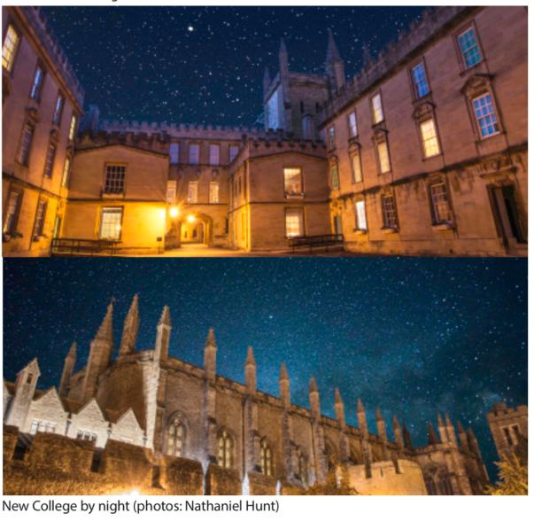
There are two photographs of college one on top of the other. Both are taken at night with hundreds of stars visible in the sky. The top photo shows garden Quad, and the bottom shows the chapel, hall, city wall and bell tower.

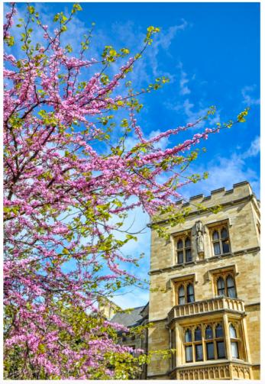
Image Description: There is a photograph of New Buildings with a tree with purple flowers taking up the left of the photo, a building taking up the right and a blue sky behind.

